**Brooklyn torah gazette**

**For parshas acharei**

**mos - kedoshi 5783**

Volume 7, Issue 32 (Whole Number 339) 8 Iyaar 5783/ April 29, 2023

**Printed L’illuy nishmas Nechama bas R’ Noach, a”h**

For a free subscription, please forward your request to [***keren18@juno.com***](mailto:keren18@juno.com)

**The Radical Hassidic Rabbi We Need More Than Ever:**

***The Kotzker Rebbe was fiercely committed to truth and authenticity.***

**By**[**Shabbos Kestenbaum**](https://aish.com/authors/486116431)

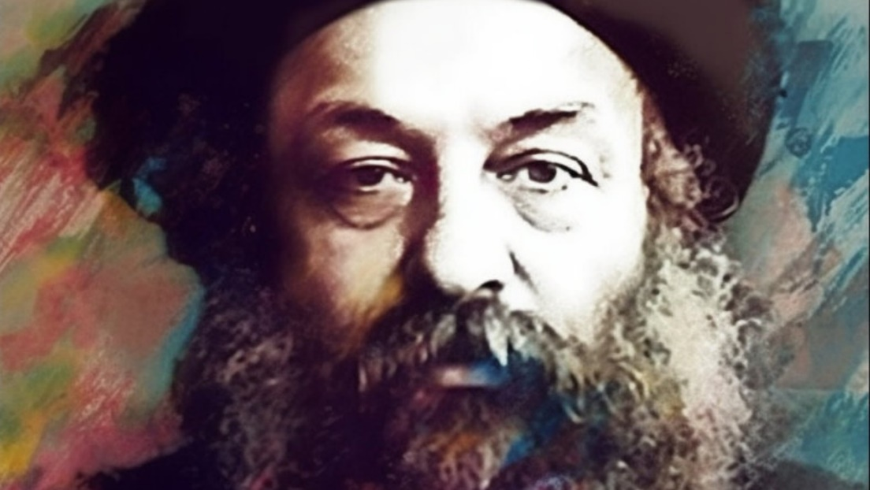

Menachem Mendel Morgenstern, the Kotzker Rebbe, was a 19th-century Hasidic Rabbi known for his sharp wit, radical teachings, and uncompromising approach to Judaism.

Despite his influence on Jewish thought, the Kotzker Rebbe was a reclusive figure who spent the last 25 years of his life living alone in the forest, scaling the heights of spirituality.

Born into a distinctly non-Hasidic family in 1787, the young Menachem Mendel became attracted to the central tenets of Hasidic thought, namely that of emotional cleaving to G-d, serious spiritual introspection, and truth. As he evolved into a spiritual figure in his own right, the Kotzker was expelled from the town of Tomaszów, as his congregants were simply too uncomfortable with his rigorous expectations of the self. Finding solace in the nearby town of Kotzk, the Rebbe would live there for the remainder of his life, never leaving the area again.

**How Prayer Can be Close to Idolatry**

Indeed, although his sons tried to carry the mantle of leadership after his death, the movement was strictly limited to the Rebbe’s lifetime, as his demands for spiritual purity were too much for later generations to adhere to. For example, the Rebbe held that prayer done simply to fulfill one’s religious obligation is nothing short of idolatry.

Prayer can only be performed when the individual subjects himself to total submission to the Divine will, something human beings typically fall short of. His expectations exceeded the religious sphere and permeated daily routines. He criticized man’s constant desire to accommodate the judgments of others, famously explaining: “If I am I because I am I, and you are you because you are you, then I am I and you are you. But if I am I because you are you and you are you because I am I, then I am not I and you are not you!"

Tellingly, the world of Kotzk is seldom studied or understood, owing somewhat to its limited acceptance in the broader Jewish community and its scrupulous standards.

**The Pursuit of Truth**

The Kotzker Rebbe was known for his radical teachings which challenged conventional wisdom. He believed that the pursuit of truth was the highest goal of Judaism, which required a willingness to question and challenge established norms and beliefs. At a time when charismatic Rabbinic leaders competed for spiritual followers, it was his disdain for such a practice that ultimately led to his isolation. Ironically, the more he rejected his growing influence, the larger his following became.

He emphasized the importance of individual responsibility, believing each person had a unique role in the world and that it was up to the individual to fulfill his or her own potential and purpose. The Kotzker would routinely chastise individuals for making the trek to Kotzk to seek a blessing from him, which was customary for a Hasidic Rebbe to give to his adherents.

He viewed a personal blessing as too often being used as a quick spiritual fix to their woes. Instead of praying for his practitioners, he would encourage them to seek their own salvation through personal reflection and repentance and take ownership of one's own spiritual journey.

The Kotzker Rebbe had no tolerance for faux pas religious piety. He believed that true religious devotion could not be measured by outward displays of religious observance, but rather by a person's inner commitment to living a life of integrity and righteousness.

**Building a Just Society**

He also had a deep concern for social equity and believed that Jews were responsible for actively working towards creating a more just society built on the precepts of truth. He believed that the wealthy and powerful had a responsibility to use their resources to help those in need. Famously, he would often cite the ideal practice of a leader: when faced with a cold snap, many opt to warm themselves in a fur coat. The true mark of the righteous is when they instead build a fire, thereby ensuring those who gather around will also be consoled.

Similarly, when his wife Glike Nay noticed their silverware had been stolen, the Kotzker was completely unperturbed. “Impossible,” he exclaimed. “The Torah explicitly teaches us not to steal. It simply cannot be, therefore, that a Jew would.” His genuine desire to live in a world strictly adhering to G-d’s will often made him unwilling, and perhaps unable, to consider that others wouldn’t.

After someone mentioned that the holiest time of the year is the last moment on Yom Kippur, the Day of Atonement before the Gates of Heaven close, the Kotzker banged his fist on the table: “No, no, and no!” he yelled. “The holiest time,” he continued, “is today. The holiest person is you, and the holiest place is right here.” Such teachings represent the essence of the Kotzker: unabashedly confident as to the spiritual heights any individual is capable of reaching.

**The Continuing Influence of the Kotzker Rebbe**

The Kotzker Rebbe was deeply respected by his followers and has continued to influence Jewish thought to this day, albeit in more subliminal ways. He deliberately burnt all of his Torah novellas and writings in a fire, horrified that people in later generations would rely on his approach to Judaism rather than devise their own.

Undoubtedly, the Kotzker would probably be furious to learn that 164 years after his death, this article was being written. Nevertheless, his authentic and unique approach to man’s relationship with the world at large and with the Creator of the world, as well as his immovable quest for authenticity makes him a surely needed figure today.

*Reprinted from the April 23, 2023 website posting of aish.com*

**How to Put Life into**

**Your Mitzvot Performance**

**From the Teachings of the Lubavitcher Rebbe**

**Rabbi Menachem Mendel Schneerson, Zt”l**

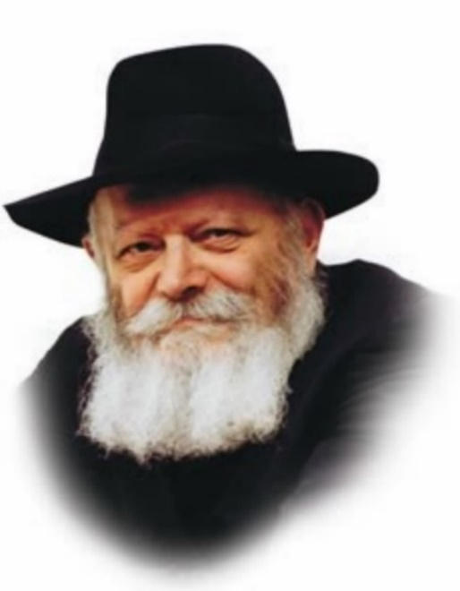

This week we read the Torah portion of Acharei which states, “And you should guard My statutes and My laws, that the person will do them, and live by them, I Am G-d.”

The Maggid of Mezrich explains that the words “and live by them – vachai bahem,” can also be translated, “and put life into them.” Thus, according to the Maggid, we learn from these words that we have to bring life into the mitzvot (commandments).

How does one bring life into the mitzvot? What can we learn from this for our relationships?

The approach to doing mitzvot can take on several different forms.

There is the person whose mitzvot and life are not interconnected. To him, there is a separation between holy and mundane. He prays with fervor, but when he does business, eats, etc., holiness and refinement are not visible.

A second person is one whose life and mitzvot are connected, he does mitzvot with all the bells and whistles. But he does them with the hope that by doing them, he will get what he wants from G-d. His drive to do mitzvot is the physical pay out. In this case it is his mitzvot bringing life into his needs.

Then there is the one whose every physical need and act is so that he can do mitzvot. He eats, he exercises, he works, and rests, just to be able to carry out G-d’s will. This is bringing life into the mitzvot; his whole life is dedicated to G-d.

Most of us at one time or another fall into the various above categories. But the goal should be to make G-d the focus, to bring life into the mitzvot. When you are G-d focused you eat differently, work differently, respond differently, etc., your every step will become filled with purpose and meaning. Of course, this is a life’s journey. One step at a time, you have the power to reach higher, and the more you do it, the more meaningful your life will become, the closer you will feel to G-d.

It is always difficult to balance between family and work, family and personal interests. When work and recreation are an escape from family, your family is resentful. But when your family knows that they are your priority because you treat them that way, and your work and recreation are so that you can be a better spouse or parent, then they will have no resentment to your work and recreation. Just the opposite, they will take pride and joy in what a great and loving spouse or parent you are.

The key is to make G-d most important to your family and your family most important to you.

May we all be blessed with meaning in our lives, closeness to G-d, and closeness to our families.

*Reprinted from the Parshat Achrei Mos 5782 edition of L’Chaim, a publication of the Lubavitch Youth Organization in Brooklyn, NY. Adapted by Rabbi Yitzi Hurwitz from the teachings of the Rebbe, yitzihurwitz.blogspot.com. Rabbi Hurwitz, who is battling ALS, and his wife Dina, are emissaries of the Rebbe in Temecula, CA.*

******************************************************************

*Upon the kohanim and all the people of the congregation shall he bring atonement.* (Lev. 16:33)

The words “of the congregation” appear to be superfluous. The Torah could have just said “upon all the people he shall bring atonement.” A congregation refers to a group of people gathered together. The Torah is emphasizing the importance of unity among the Jewish people. When the people are gathered together, we are able to beseech G-d to forgive our transgressions. (Be’er Moshe)

*In the cloud I will appear upon the ark-cover* (Lev. 16:2)

This teaches that we must never despair even in the worst of the times, for G-d’s Presence rested upon Israel precisely “in the cloud.” No matter how dark or hopeless a situation appears we must never give up or become dejected. (Rabbi Meir Shapira of Lublin)

*Reprinted from the Parshat Achrei Mos 5782 edition of L’Chaim*

**Rabbi Berel Wein on Parshas**

**Acharei Kedoshim 5783**

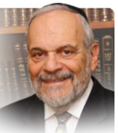

Among the many commandments and values that are represented in this week’s double parsha, special attention seems to being paid to the intimate and marital relationships between people. The Torah lists for us those relationships which are considered to be incestuous, immoral and forbidden. There is perhaps no area of human behavior so sensitive and yet so dissolute and dangerously self-destructive as these liaisons and relationships.

According to the popularization of Freudian psychology, it is the sexual drive more than anything else that is the energy source for human behavior. The Torah looks not to deny this basic drive, it never preaches celibacy, but rather it looks to channel and control this activity, turning it from something potentially illicit and harmful to something that is holy and creative.

In order to accomplish this, the Torah imposes a set of limitations, inhibitions and rules to govern and sanctify such human behavior. In effect, the Torah teaches us that our sexual drive is a neutral commodity. It is rather the circumstances and structure that surround the use of this drive that determines its probity, and holiness. That is the key idea that lies behind the commandments that appear in these parshiyot – discipline, sensitivity, correctness behavior and a sense of positive purpose.

Be holy and sanctified the Torah tells us – that is our goal. How to arrive there is what the commandments, individually and collectively, come to teach us. And the road is paved with self-discipline, self-control and a devotion to duty and responsibility. These parshiyot also emphasize to us the Torah’s view regarding the treatment of other human beings. The Torah bids us to love, to respect, and to tolerate others, to become a holier person. Piety in matters that are, so to speak, between man and G-d are of prime importance in Jewish life.

But of equal importance is the correct relationship between humans and their fellow human beings. One cannot be a holy person through ritual piety and scholarship alone. Ramban advances the idea that the possibility of being obnoxious and disgusting, even within the confines of the Torah, so to speak, exists. How we deal with other human beings is a crucial part of being a holy person.

It is far easier to deal with an unseen and inscrutable Divinity than to have to deal with a real human being face to face. When people differ with us, oftentimes they are not cognizant of our needs and desires, and can prove to be annoying and difficult. How are we to deal with such people? The Torah prescribes the same formula for dealing with others as it does for dealing with our innate drives as described above – patience, sensitivity, self-discipline, and retention of the goal of being holy.

An awareness of circumstances and situations that govern all of the commandments of the Torah also relate to our interpersonal behavior, one with another. The Torah is always to be viewed as a unit, as something whole and inseparable. That is the way to embark on the road to holiness.

*Reprinted from the current website of rabbiwein.com*

******************************************************************

*In the cloud I will appear upon the ark-cover* (Lev. 16:2)

This teaches that we must never despair even in the worst of the times, for G-d’s Presence rested upon Israel precisely “in the cloud.” No matter how dark or hopeless a situation appears we must never give up or become dejected. (Rabbi Meir Shapira of Lublin)

*Reprinted from the Parshat Achrei Mos 5782 edition of L’Chaim*

**Rav Avigdor Miller on The Peak Before The Holocaust**

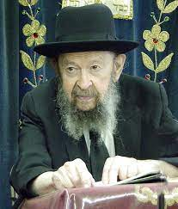

**QUESTION:** Why didn’t the tremendous zchus of the tzaddikim in the time of the Holocaust save six million Jews? The kehillos in Europe and the Torah learning was its peak.

**ANSWER:** Oy-yoh-yoy!  How many times do I have to repeat this? I see people are living in such darkness. But you can’t blame them because there are a lot of rabbonim who are fellow conspirators in promoting this darkness.

Judaism in Europe was not at its peak! It was approaching the peak of the bottom! I’ll give you an example. In Lithuania, there were daily Jewish newspapers; one for the Left Zionists called the Tze-Es; Zionist Socialists, a daily newspaper.  There was a daily newspaper for the general Zionists, a daily newspaper for the Revisionists and another daily newspaper – I forget which one.  Daily newspapers for Jews to read. These were newspapers for Jews, not for the gentiles.

But for Orthodox Jews, there was no daily and no weekly and almost no monthly.  A little thing was published once a month at a precarious existence; it was published by the Tzeiri Agudas Yisroel and even that didn’t appear regularly.

Now the question is who was doing all this reading? Human beings were reading it.  And not Lithuanians, not gentiles. Jews! Jews were doing all this reading! Now, what was in those newspapers, the daily newspapers?  Hostility to Judaism.  Attacks on rabbonim.  Ridicule of Torah and mitzvos. It was filled with hostility and ridicule. And that means that the Jewish nation in Europe before the Holocaust was reading newspapers every day with poison against Torah, against da’as Torah. They were being poisoned.

Where did the roshei yeshiva or the tzaddikim that existed have an opportunity to say anything?  Once a month in that tiny little newspaper of Agudas Yisroel.  So, it means that the ear of the public belonged to the reshaim, which means that the masses of the Jewish people were going lost.

What are you saying that Judaism in Europe was as its peak?! A yeshiva man, if he walks out, let’s say, in Staten Island in some very assimilated Jewish neighborhood, will Jews call him names?  Jews might not take to him, they might consider him alien, a stranger, but that’s all. But in Lithuania, a yeshiva bochur in many places was called names by the Jews!  They looked down on him!  They called him patron! They called him a parasite. You don’t realize how far the Jews in Europe had moved away from Judaism. There was a lot of chillul Shabbos!  There was a lot of atheism.  The youth had no longer any connection with Judaism.

What kind of talk is this?!  It’s really a nuisance to have to repeat this again and again.  The Jews in Europe were not tzaddikim.  There were some tzaddikim in Europe, but it was very far from the peak and they never were as bad as they were before World War II.

*Reprinted from a recent Toras Avigdor email based on Rabbi Miller’s Tape # 215 from April 1978.*

**Who Were the Cantonists?**

**The Tsar's Jewish Child-Soldiers**

**By**[**Menachem Posner**](https://www.chabad.org/search/keyword_cdo/kid/12145/jewish/Posner-Menachem.htm)

The cantonists were Jewish boys in the Russian Empire who were forcibly taken to camps (“cantons”) where they were trained to become soldiers in the Tsar’s army between 1827 and the end of the 1850s. Often snatched as young as six years old, they became soldiers when they turned 18 and were then made to serve as long as 25 additional years. Cut off from their families and communities, the boys were under tremendous pressure to abandon their Judaism, and many displayed heroic devotion to the faith of their ancestors.

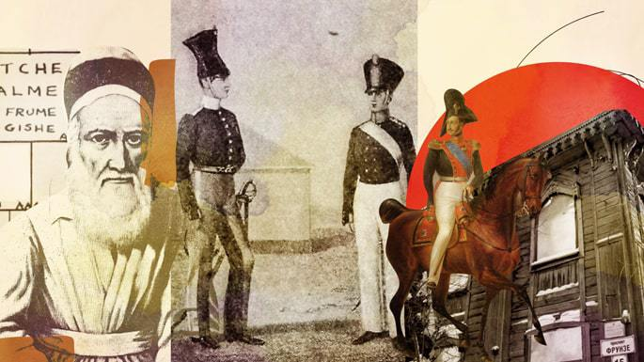

***Art by***[***Sefira Lightstone***](https://www.chabad.org/3159160)

**The Missing Branch of the Family Tree**

Leafing through an old family tree released around 70 years ago, I noticed a short note next to someone I had never heard of: My great-great-great-great-great uncle, Pinchas Posner (Pevzner).

On the branch of the tree where his nuclear family appears, Pichas’s name was originally not included alongside his five siblings (one of whom is my direct ancestor, Aharon Ber). There is just a small asterisk that points the reader to the bottom of the page where Pinchas’s name was added in small letters.

In the introduction to the family tree, we are told that Pinchas was taken to the Russian army at the age of six and that some of the elder members of the family did not deem him worthy of being included in the book, as he had “left the family.”

Unfortunately, Pinchas was far from unique.

Pinchas was a “cantonist,” a Jewish boy who was forcibly taken to a military school (“canton”), where he was not given kosher food or otherwise allowed to live as a Jew. After the boys turned 18, they were drafted into the military.

Originally a 25-year term, the military service was subsequently diminished to 18 and then 14 years. Meaning that boys like Uncle Pinchas could have been robbed of more than 30 years of life.

The era of the Jewish cantonists began in 1827 when Jewish children, as well as Jewish adults, were forcibly taken to cantons, military schools, which had previously served primarily the children of Russian soldiers. While some were stationed close to the existing Jewish communities in White Russia, where our family lived, others were stationed in far-off Siberia, virtually cut off from home and hearth. Yet even there, many of the boys clung to the faith of their childhood, determined to observe Judaism to the best of their meager knowledge and abilities.

**From Home to Hell**

The boys were selected by Jewish community (*kahal*) officials, who were required to furnish a specific quota of conscripts. Since the well-connected could often do whatever it took to protect their children, it was typically the sons of poor families, widows, and others on the margins who were taken.

This placed tremendous pressure on the leaders, who were often faced with the terrible choice of determining whom to send. Pinchas’s great-grandfather Berel, the earliest known ancestor of our family, was one such leader, who sent both Jewish and non-Jewish boys to the draft in equal proportions. This so angered the non-Jewish peasants, who wanted only Jewish boys to be drafted, that they doused his clothing in alcohol and set him aflame.

In many places, roving kidnappers (*khappers* in Yiddish) would take children off the streets and furnish them to the recruiting authorities at the behest of *kahals*desperate to fill their quotas while protecting their own children. As could be expected, these men were reviled by their fellow Jews.

Their efforts were countered by brave communal activists. [Loosely coordinated](https://www.chabad.org/library/article_cdo/aid/85450/jewish/Appendix-B.htm) by Rabbi Menachem Mendel—the third Rebbe of Chabad—one such group of activists worked in utter secrecy and used any means possible to wrest the children from the hands of the *khappers*, including bribery and falsification of death certificates.

The trip from home to the canton was often fraught with danger, with boys suffering from hunger, exposure, illness, and exhaustion even before they arrived at their battalions.

**Pressure to Convert**

Life in the cantons was brutal and the children were habitually starved. Treatment for illness included beatings, and the mortality rate was high (and appeared to be even higher among the non-Jewish children).

Under these conditions, the boys were subjected to extreme pressure to abandon Judaism, from military brass and clergy who offered financial incentives (25 rubles by order of Tsar Nicolas I himself), promotions, and breaks from incessant beatings in exchange for converting. The campaign to convert as many of the boys to Russian Orthodoxy as possible was the work of the Tsar, who micromanaged the project, demanding frequent reports on how many boys had been converted, rewarding priests responsible for large numbers of converts and berating those who fell behind.

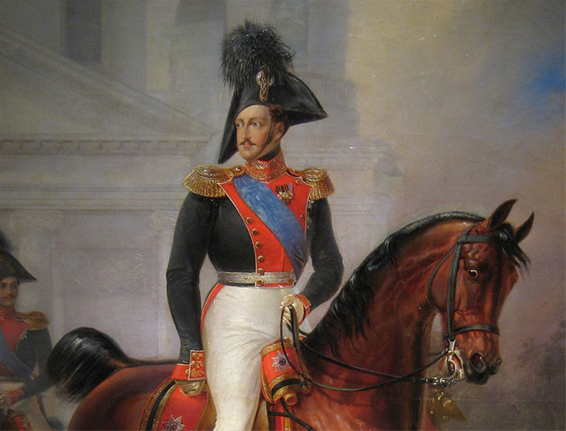

**Nicholas I of Russia**

Yet despite the [immense pressure](https://www.chabad.org/kids/article_cdo/aid/5358/jewish/Simchat-Torah-of-a-Cantonist.htm) and suffering that was their lot, the majority of the cantonists maintained their Jewish identity, even though they often lacked basic knowledge of Judaism since they had been taken from home before they had a chance to learn to read Hebrew, celebrate the holidays, etc.

To Nicolas, the purpose of enlisting and converting the boys was pragmatic. He believed that an army would run better—as would his empire as a whole—if everyone worshiped, spoke, and believed in the same manner. And the best way to do that was to force them into the Russian military training machine, where they would become obedient, homogenous Russian subjects.

The repeated failure to convert the majority of recruits infuriated the Tsar, who tried firings, cash incentives, shaming and more to cajole the church and military establishments to ramp up the production of new Christians.

**Strength to Resist**

At times, the cantonists were assisted and encouraged by Jewish military men, who taught, guided and encouraged the boys. Jewish civilians working on base, such as cobblers and tailors, also provided support.

They were also allowed to attend synagogues and Jewish celebrations in nearby communities, which strengthened their resolve.

When Rabbi Menachem Mendel was in St. Petersburg to attend the rabbinical convention of 1843, he was granted a special permit to address the Jewish soldiers serving at the military fortress on the nearby island of Kronshtadt.

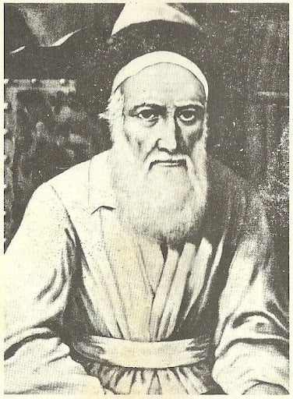

**Rabbi Menachem Mendel of Lubavitch (the Tzemach Tzedek)**

He was greeted by the waiting soldiers, who said to him: “Rebbe! We’ve been toiling all morning to prepare for your coming, polishing our buttons in your honor. Now it’s your turn to work hard: polish our souls, which have been dulled and coarsened by our many years of disconnection from Jewish life.”[1](javascript:doFootnote('1a5906591');)

Upon graduation and their transition into the military proper, the Jewish soldiers proved to be as adept as their non-Jewish peers, if not more so, having well retained the various skills and tactics taught to them.



**The Soldatskaya Synagogue, or Soldiers’ Synagogue, a unique wooden structure that was built in 1907 by Jewish soldiers who had been kidnapped as children to serve in the Russian Imperial Military, was formally returned to the Jewish community of Tomsk, Siberia, on Feb. 1.**

**The Long-Term Effects**

The sad era of the cantonists came to a gradual close following the 1855 death of Nicolas and the ascent of Alexander II, who canceled the draft of minors, although it continued through the end of the 1850s.

Scandalizing reports of forced conversions were surfacing, and converted cantonists (some of whom still wore *tzitzit*and prayed with hidden prayer books) were clamoring to openly return to the faith of their ancestors.

In 1858 an order was issued, forbidding the use of force in convincing Jewish cantonists to convert to Christianity.

But many issues persisted, with cantonists and former cantonists fighting for their right to use their proper Jewish names and otherwise [live full Jewish lives](https://www.chabad.org/library/article_cdo/aid/59074/jewish/The-Cantonists-Minyan.htm). Some did so quietly, maintaining their official identity as Christians but living as Jews in private.

It took a full 15 years for Alexander to dismantle the cantonist institution, and it was not until 1905 that many aging cantonist converts finally gained official approval to reclaim their Jewish identity.

**Forming New Communities**

Following discharge, the cantonists who survived were granted certain rights, such as living in parts of the Russian empire normally off-limits to Jews. Thus, they formed the nucleus of the Jewish communities in places such as Finland (which is [no longer part of Russia](https://www.chabad.org/news/article_cdo/aid/5562460/jewish/Finlands-New-Chabad-Center-in-Downtown-Helsinki-Builds-on-Storied-History.htm)) and Siberia (where a [Cantonists’ Synagogue](https://www.chabad.org/news/article_cdo/aid/3935737/jewish/Siberian-Wood-Synagogue-Built-by-Jewish-Child-Soldiers-Returned.htm" \o "Siberian Wood Synagogue Built by Jewish Child Soldiers Returned) still stands).

There is record of Rabbi Shmuel—the fourth Chabad Rebbe—encouraging Jews, who for whatever reason had rights to live in these areas—to use the opportunity to guide these sincere men, who so wanted to live Jewishly but had never had the chance to learn even the rudimentary elements of Jewish belief and practice.[2](javascript:doFootnote('2a5906591');)

Even when allowed to return home, many cantonists did not want to, sensing that they would be shunned by communities who did not understand their experience and for whom their very existence was a mark of shame.

And whatever happened to Uncle Pinchas?

Family lore reports that he returned home but once to reproach his family for not having inculcated him with the Jewish knowledge and inspiration he would need to withstand the pressures placed upon him to convert.

And with that, he departed and was never seen again.

*This essay is dedicated to the soul of Pinchas son of Yitzchak Zalman and Frumma Gisha.* [3](javascript:doFootnote('3a5906591');)

**FOOTNOTES**

[1.](https://www.chabad.org/library/article_cdo/aid/5906591/jewish/Who-Were-the-Cantonists.htm" \l "footnoteRef1a5906591) See: [Sand and Water](https://www.chabad.org/library/article_cdo/aid/166403/jewish/Sand-and-Water.htm)

[2.](https://www.chabad.org/library/article_cdo/aid/5906591/jewish/Who-Were-the-Cantonists.htm" \l "footnoteRef2a5906591) See letter of Igrot Kodesh Admur Rayatz, vol. 7., page 21, quoting the directive given by Rabbi Shmuel to a Jewish watchmaker who had moved from the heavily Jewish city of Polotzk to Vladimir, where virtually all the Jews were former cantonists or military men.

[3.](https://www.chabad.org/library/article_cdo/aid/5906591/jewish/Who-Were-the-Cantonists.htm" \l "footnoteRef3a5906591) Much of the information provided was culled from *“Let the Children Come to Me”: Jewish Minors in the Cantonist Battalions* by Dr. Yohanan Petrovsky-Shtern, who also graciously reviewed this article and provided invaluable insights and corrections.

*Reprinted from the current website of Chabad.org*